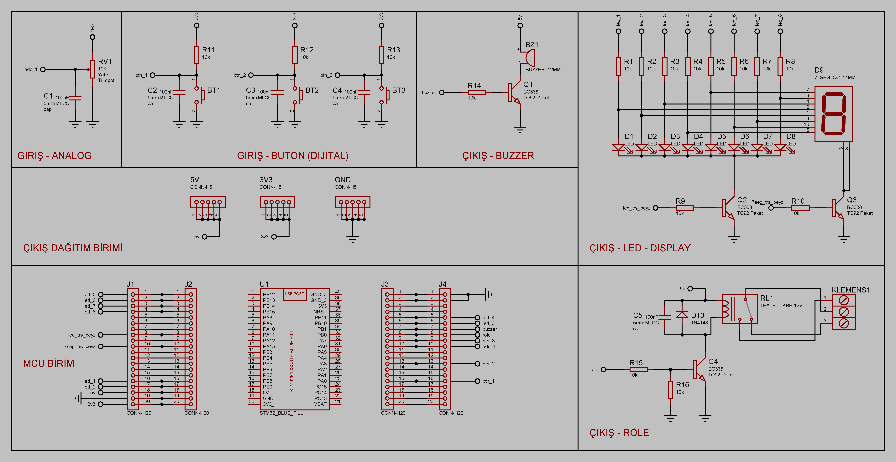

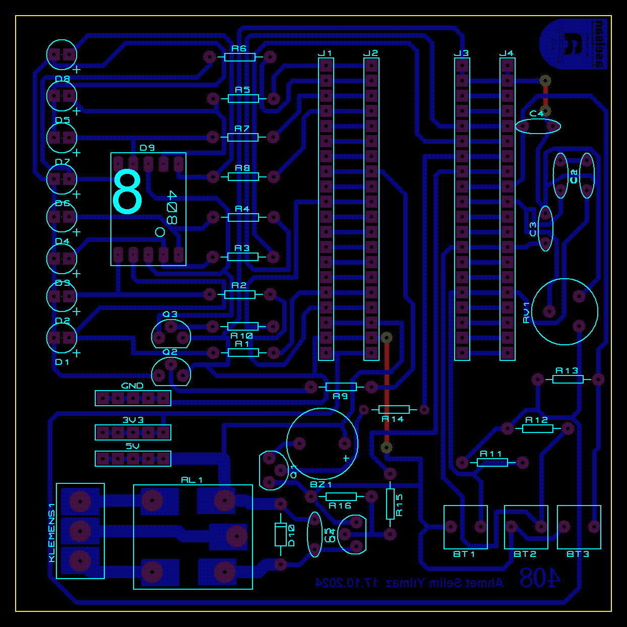

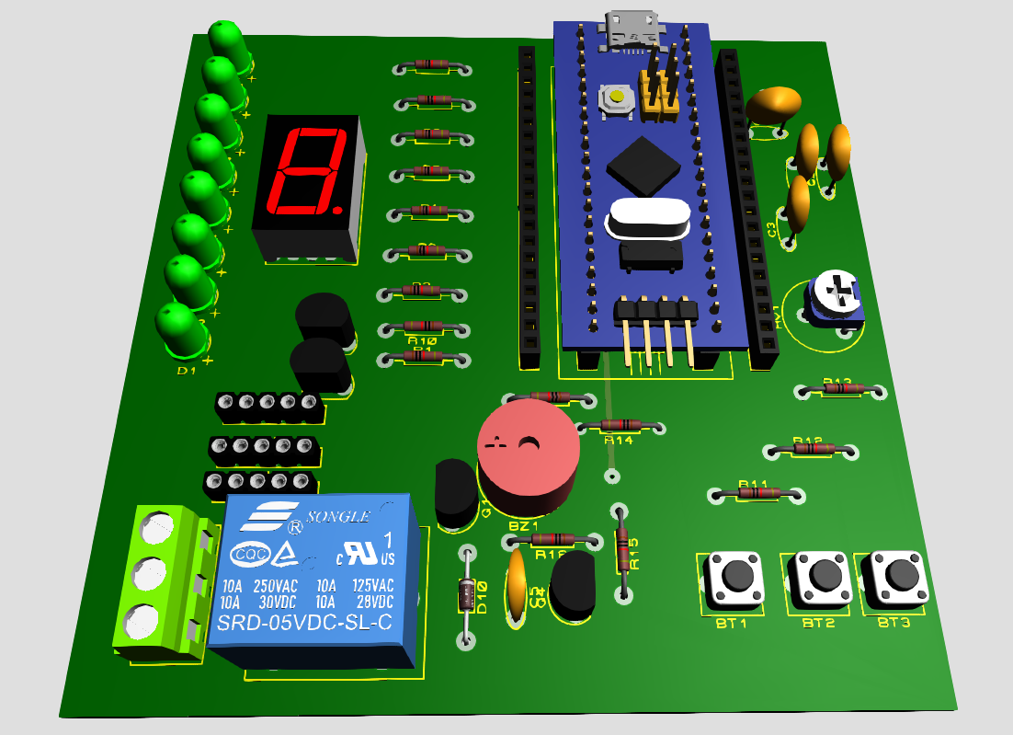

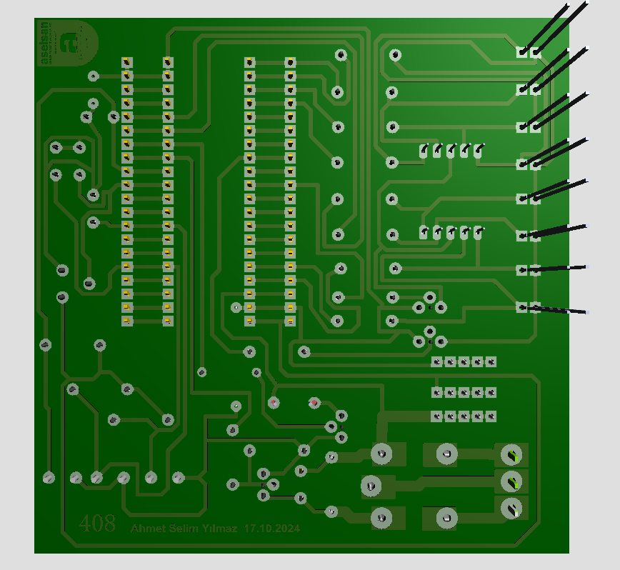

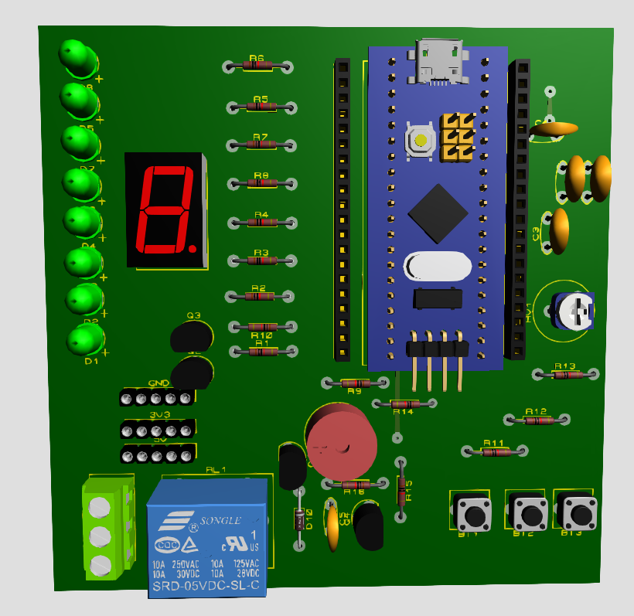

|  |  |  |  |  |  |  |  |  |  |
| --- | --- | --- | --- | --- | --- | --- | --- | --- | --- |
| **Bill Of Materials for 408 STM-32 Devre** | | |  |  |  |  |  |  |  |
|  |  |  |  |  |  |  |  |  |  |
| **Design Title** | | | 408 STM-32 Devre | |  |  |  |  |  |
| **Author** | | |  | |  |  |  |  |  |
| **Document Number** | | |  | |  |  |  |  |  |
| **Revision** | | |  | |  |  |  |  |  |
| **Design Created** | | | 24 Ekim 2024 Perşembe | |  |  |  |  |  |
| **Design Last Modified** | | | 21 Kasım 2024 Perşembe | |  |  |  |  |  |
| **Total Parts In Design** | | | 50 | |  |  |  |  |  |
|  |  |  |  |  |  |  | Totals |  |  |
| **Category** | **Quantity** | **References** | **Value** | **Stock Code** | **Unit Cost** |  | **Category** | **Quantity** | **Unit Cost** |
| Capacitors | 5 | C1-C5 | 100nF |  |  |  | Modules | 0 | ₺0,00 |
| Resistors | 16 | R1-R16 | 10k |  |  |  | Capacitors | 5 | ₺0,00 |
| Integrated Circuits | 1 | U1 | STM32_BLUE_PILL |  |  |  | Resistors | 16 | ₺0,00 |
| Transistors | 4 | Q1-Q4 | BC338 |  |  |  | Integrated Circuits | 1 | ₺0,00 |
| Diodes | 8 | D1-D8 | LED |  |  |  | Transistors | 4 | ₺0,00 |
| Diodes | 1 | D9 | 7_SEG_CC_14MM |  |  |  | Diodes | 10 | ₺0,00 |
| Diodes | 1 | D10 | 1N4148 |  |  |  | Miscellaneous | 14 | ₺0,00 |
| Miscellaneous | 3 | 3V3,5V,GND | CONN-H5 |  |  |  | **Total** | **50** | **₺0,00** |
| Miscellaneous | 4 | BT1-BT3,KLEMENS1 |  |  |  |  |  |  |  |
| Miscellaneous | 1 | BZ1 | BUZZER_12MM |  |  |  |  |  |  |
| Miscellaneous | 4 | J1-J4 | CONN-H20 |  |  |  |  |  |  |
| Miscellaneous | 1 | RL1 | TEXTELL-KBE-12V |  |  |  |  |  |  |
| Miscellaneous | 1 | RV1 | 10K | Digikey 3214G-103EDKR-ND |  |  |  |  |  |

**STM32F103C8T6 MİKRO DENETLEYİCİ TEST GELİŞTİRME KARTI**



**11/A 408**